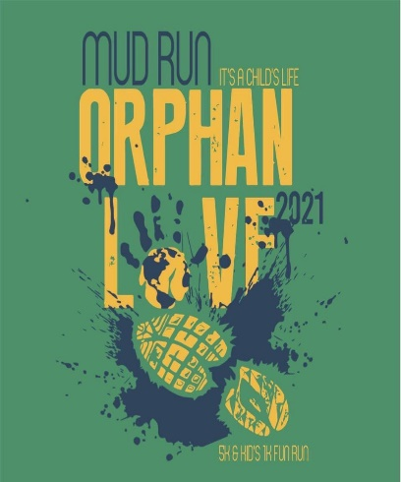
Sponsorship Options
Its A Child's Life Foundation is a registered 501(c)(3) non-profit organization that is comprised of families with a heart for children that want to make a positive impact on the current orphan statistics.
It’s A Child’s Life Foundation was set up to aide in achieving a common goal: Improvement of the lives of children through adoption, fostering, mentoring and support.

The Orphan Love Mud Run is one of our annual events, set up to assist families with their adoption expenses. Adoption, whether domestic or international, comes with a large financial burden to the family and on average ranges from $20,000-$40,000 to complete the process. For many families, the only way to be able to adopt at this cost, is through fundraising. The families we support through the mud run have all completed an application process, have an approved home study and are currently in the process of adopting through an accredited agency or privately through an attorney. Each fundraising family is required to get $500 worth of sponsorships and they must participate either by running or volunteering on the day of the run.

The BIGGEST way we are able to raise money for these families is through our sponsors. 100% of the proceeds from the mud run benefit local, national and international children in need through adoption, foster care and through missions to prevent family separation due to poverty. We have been able to raise over to $160,500 for 53 families and 25 non-profit donations that help with vulnerable children in the past 8 years of doing this run and we couldn’t do it without YOU! Your sponsorship helps to bring orphaned children into a forever family and we are grateful for you!

The Orphan Love Mud Run will take place on September 18th, 2021

- Platinum: $5,000 (Your name/logo placed: at the start and finish line, in a LARGE spot on the back of the shirts, on the finisher backdrop for runner photographs and on our website.)

- Gold: $3,000 (Your name/logo placed: in a LARGE spot on the back of the shirts, on the finisher backdrop for runner photographs and on our website.)

- Silver: $1,000 (Your name/logo placed: in a MEDIUM spot on the back of the shirts, on the finisher backdrop for runner photographs and on our website.)

- Bronze: $500 (Your name/logo placed in a MEDIUM spot on the back of the shirts and our website)

- Copper: $100 (Your family or company’s name listed in SMALL font on the back of the shirts to the
first 20 donations made, as well as you will be listed on our website)

***The DEADLINE to get your company’s logo or family’s name printed on advertising material is
August 18th, 2021 and will require that a clear image be emailed to us at contact@itsachildslife.org

To help us with Tax Deduction Letters, please complete the following:

Donation Amount: $

Company Name:

Contact Name(s):

Address:

City, State, Zip:

Phone:

Email Address:

ARE YOU SPONSORING ON BEHALF OF ONE OF OUR ADOPTING FAMILIES?

If so, please fill their names in here:

Please return this form with an enclosed check made out to I t’s A Child’s Life, to the address below:

It’s A Child’s Life
Attn: Sponsorship
PO Box 172
Ada, OK 74821

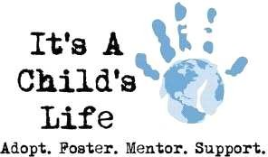
In accordance with IRS charitable guidelines please understand that It’s A Child’s Life Foundation has complete control and administration over the use of donated funds. This is particularly important because of our assistance to families who are adopting. The necessity of our control of donated funds is to ensure that your gift is charitable and being made to It’s A Child’s Life Foundation charitable mission, and not to a specific family (which does not count as a charitable gift). It’s A Child’s Life Foundation prayerfully considers the requests and preferences of donors to support a specific program or fund, but closely adheres to the IRS standards referenced above to maintain administration and control of all donated fund

